Welcome to the 2017 ANZA CBT
Pre-Conference, Conference and Post-Conference Workshops
23rd,24th and 25th November 2017

Contents

Administration and general information 3

Timetable 5

Presentations 8

We would like to thank our sponsors for their generous support:

Major Sponsor: ACC sponsoring the lunch on conference day

Contributing Sponsor: Te Pou

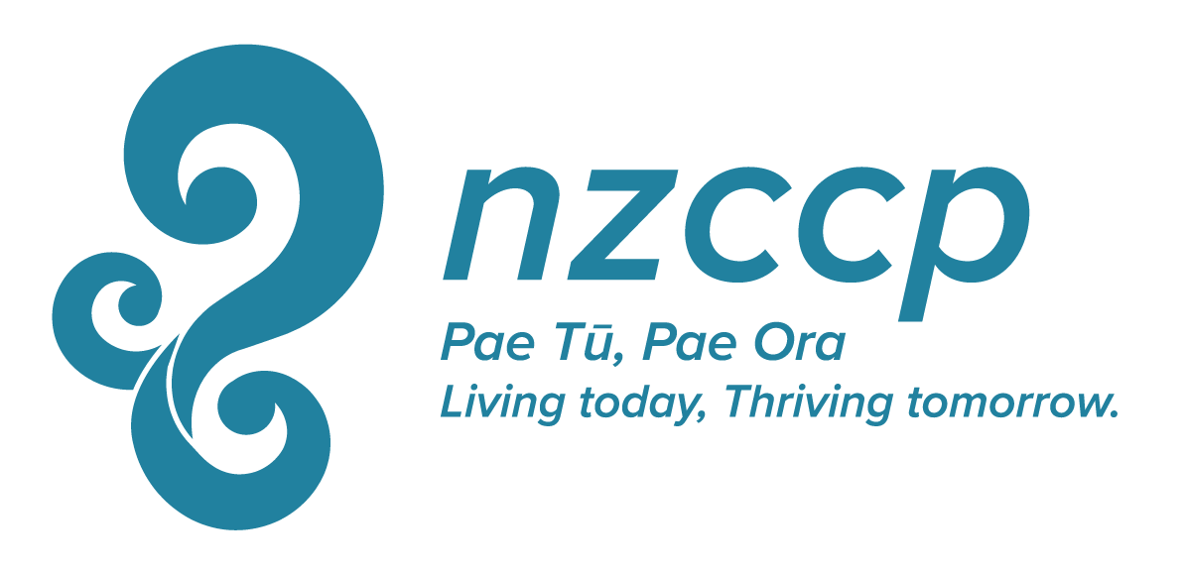

Contributing Sponsor: NZCCP- New Zealand Clinical Psychologists

ADMINISTRATION AND GENERAL INFORMATION

Conference Registration Desk
The registration desk will be open between 8a.m – 8.50am Thursday 23rd, Friday 24th and Saturday 25th. The registration staff will be available during the conference. Please do not hesitate to ask for information or assistance.

Notice Board
The conference notice board will be placed in the registration area and will be used to display conference information, programme changes, announcements, personal messages, and so on. Please check the board regularly.

Cell Phones & Other Technology
If at all possible please switch off all cell phones and items that may interrupt proceedings. If you must have a cell phone on, please ensure it is on silent or vibrate mode only and if you need to answer it please do so in a manner that causes the least disruption to others.

Lost and Found
Please report lost or found items at the registration desk.

Name Tags
Your conference pack includes a name tag. Please wear this at all times. It is your passport into sessions, meetings, social functions and meal breaks.

Meal Breaks
Morning and afternoon teas and lunches are provided as part of the workshops and conference. All meals will be served in the Square restaurant which is located on the first floor.

Social Events
Whakawhanaungatanga – an opportunity to make new connections and re-establish old ones will be held with wine and nibbles on Thursday 23rd at 5.15p.m to 7p.m

Parking
Novotel Christchurch Cathedral Square offers a valet parking service on a first come, first served basis. We are delighted to offer you $10 day parking for the duration of your event or 24 hour valet car parking at $35 per vehicle, alternatively public parking options surrounding the hotel which include a Wilson’s public car parking lot directly adjacent to the hotel. The costs for this are currently $2/hour, $5/early bird and $7/overnight.

Dietary Requirements
Delegates who have not indicated dietary requirements upon registration should inform the registration staff as soon as possible. If this is not done prior to the conference please notify the registration desk upon arrival to allow for arrangements to be made. Special meals will be clearly identifiable. If you have not indicated any particular dietary requirements then please do not eat these meals or someone else will miss out.
Guidelines for presenters at conference
Please load your presentation onto the laptop in the room you are presenting in the break immediately before your presentation slot. There will be a helper in the room to assist you with this if needed. All rooms will have a data projector and a laptop, as well as whiteboard and flip charts which you are welcome to use. If you requested other equipment this will also be in the room. There will be a session chairperson (Simone Kinley) who will introduce you and keep time for you.

Health
In medical emergencies the hotel Coordinator is to be contacted immediately to assess the situation and if required medical services will be contacted, e.g. ambulance. Please do not hesitate to contact hotel staff or workshop organisers if you feel unwell.

Emergency Evacuation
In the unlikely event of an emergency, please follow the directions of the hotel staff or the conference organisers. The emergency evacuation assembly point is in the car park at the front of the hotel. In the event of an earthquake please stay in the room and await further instructions from staff.

Smoking
Smoking is not allowed in the Novotel.

Airport Transport
The Christchurch airport is approximately 10km’s. Transport to and from the airport is available by shuttles and taxis.

Protocol for Opening and Closing Ceremonies
Please note that these are guidelines only. Some tikanga differ with other Iwi.

Mihi Whakatau - Welcoming and Caring for Visitors
Involves the encounter between two groups of people, tangata whenua (the hosts or people of the marae) and the manuhiri (visitors).

Te Whakawatea -The Farewell
This signals the conclusion of the hui (gathering). This is an informal time for the manuhiri to show appreciation express opinions relating to the hui and give thanks, and will conclude with a closing karakia (prayer)

The Christchurch 2017 Conference Organising Committee:
Ron Chambers, Simone Kinley, Janna Gresham, Kishion Dee, Becky Baichoo and Angie Spencer.
Special thanks to the executive committee for their support and Aramis Dennan for his amazing web skills.

PRE-CONFERENCE WORKSHOP
Thursday 23rd November 2017
8a.m-8.50a.m | Registration at the Novotel, Christchurch
Coffee and Tea provided.
Early morning snacks will be provided.
9a.m-9.10a.m | Welcome
9.10a.m-11a.m | Pre Conference Workshop  CBT for depression: It's not so easy after all  David A. Clark
11a.m-11.30a.m | Morning Tea
11.30a.m-1.30p.m | Pre Conference Workshop continues
1.30p.m-2.30p.m | Lunch

2.30p.m-4.50p.m | Pre Conference Workshop continues
4.50p.m-5p.m | Closing
5.15p.m-7p.m | Drinks and Nibbles, please join us for wine and platters

CONFERENCE DAY
SCHEDULE OF SPEAKERS-FRIDAY 24TH NOVEMBER 2017
8a.m-8.50a.m | Registration at the Novotel, Christchurch
9a.m-9.20a.m | Welcome
9.20a.m-10.20a.m | Is the Devil in the Detail: CBT for Clinical Perfectionism  Dr Roz Shafran
10.20a.m-10.40a.m | Morning Tea
10.40a.m-11.40a.m | Keynote Address: Mental Intrusions: the role of spontaneous thought and the emotional disorders  David A. Clark
11.40a.m-12.00p.m | Talking Therapies  Te Pou, Jo Van Leeuwen
12.00p.m-12.30p.m | The other cognitive problem in depression-should we be utilising cognitive re-mediation in CBT  Dr Jenny Jordan
12.30p.m-1.30p.m  1p.m-1.30p.m | Lunch  AnzaCBTAGM
1.30p.m-2.30p.m | Shame in the treatment of those presenting with trauma disorders: Presentation issues and therapeutic considerations  Dr Martin Dorahy
2.30p.m-3.30p.m | Cultural Workshop  The Te Pounamu Model.  Leonna Manna
3.30p.m-3.50p.m | Afternoon Tea
3.50p.m-4.10p.m | What Prisoner?  Carol Christopher

4.10p.m-4.30p.m | Summary and final comments

4.30p.m-4.45p.m | Close

Post Conference Workshop
Saturday November 25th 2017
8a.m-8.50a.m | Registration at the Novetel, Christchurch
 | Coffee and Tea provided
9a.m-9.10a.m | Welcome
9.10a.m-10.30a.m | Post Conference workshop  Modified CBT for persistent Anxiety and Obsessions  David A. Clark
10.30a.m-11.00a.m | Morning Tea
11.00a.m-12.30p.m | Post Conference workshop continues
12.30-1.30p.m | Lunch
1.30p.m-3.30p.m | Post Conference workshop continues
3.30p.m-3.50p.m | Afternoon tea
3.50p.m-4.10p.m | Post conference workshop continues

4.10p.m-4.30p.m | Summary and final comments
4.30p.m-4.45p.m | Close

PRE CONFERENCE WORKSHOP
Thursday 23rd November 2017

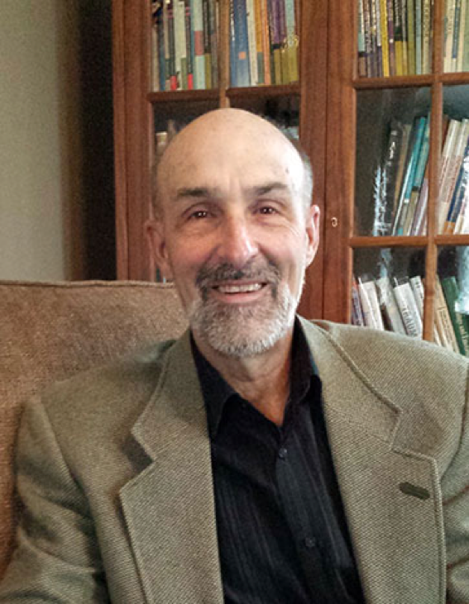
Dr David A.Clark
'CBT for depression: It's not so easy after all'

David A. Clark is Professor Emeritus with the Department of Psychology, University of New Brunswick Fredericton, where for 26 years he taught, conducted research and trained dozens of graduate students in clinical psychology. After receiving a PhD in psychology from the Institute of Psychiatry, University of London, UK in 1984, he obtained further training in cognitive therapy under Aaron T. Beck, MD. He has published over 150 scientific articles and papers on cognitive theory and therapy of depression and anxiety disorders with funding obtained from the Social Sciences and Humanities Research Council of Canada, Canadian Institutes of Health Research, and the Foundation for Cognitive Therapy. He has co authored several peer-reviewed papers and books with Dr. Beck including “Scientific Foundations of Cognitive Theory and Therapy of Depression” (Wiley, 1999), Cognitive Therapy for Anxiety Disorders (Guilford, 2010), and The Anxiety and Worry Workbook (Guilford, 2012), as well as single authored works such as Cognitive Behavioural Therapy for OCD (Guilford, 2004) and The Mood Repair Toolkit (Guilford, 2014). He continues to offer training workshops worldwide and maintains a part-time private practice. He is a Founding Fellow and trainer/consultant with the Academy of Cognitive Therapy, a supervisor with the Beck Institute, Fellow of the Canadian Psychological Association, and recipient of the Aaron T. Beck Award for Significant and Enduring Contributions to Cognitive Therapy in 2008. He is currently writing a workbook for New Harbinger Publications and Little Brown UK entitled Controlling Your Mind: A Workbook for Anxiety, Depression and Obsessions.

Cognitive therapy (CT) began as a treatment for depression. Over the years numerous CT studies have reported clinical effectiveness of 60% or greater (DeRubeis et al., 2005), lower relapse rates, improved prefrontal cortical functioning, and clinical efficacy in real-world clinical settings (DeRubeis, Siegle & Hollon, 2008; Gyani, Shafran, Laynard & D.M. Clark , 2013). However recent evidence suggests that effect sizes for psychological treatments of depression are overestimated by 25% due to publication bias (Drissen et al., 2015). Clearly, there is considerable room for improvement in the delivery of CT for depression. This workshop focuses on specific clinical features of depression that complicate treatment of the disorder. Topics addressed include depressive rumination, unwanted intrusive thoughts including traumatic intrusions, avoidance and procrastination, perfectionism, reassurance seeking and dependency, and heightened suicidality. Emphasis is placed on cognitive and behavioural intervention strategies that address each of these issues and improve treatment effectiveness Throughout the workshop case illustration, role play demonstrations, problem-oriented case consultation, and participant exercises are employed to enhance the cognitive therapy skills of attendees.
Workshop participants will learn:
a) alternative interventions for a type of spontaneous thought that is unresponsive to standard cognitive restructuring of depression
b) to identify and treat depressive rumination
c) to utilize specific cognitive strategies for hopelessness and heightened suicide risk
d) to take a strategic approach to procrastination and avoidance
e) about the cognitive formulation and treatment of perfectionism
f) how to deal with dependency and reassurance seeking in the therapeutic relationship

CONFERENCE DAY
Friday 24th November 2017
Dr David A.Clark
Keynote Address
'Mental Intrusions: the role of spontaneous thought and the emotional disorders.'

Dr Roz Shafran

'Is the Devil in the Detail: CBT for Clinical Perfectionism'

Roz Shafran, PhD, is Professor of Translational Psychology at the Institute of Child Health, University College London, United Kingdom. She is the founder and former director of the Charlie Waller Institute of Evidence-Based Psychological Treatment, Associate Editor of Behaviour Research and Therapy, and scientific co-chair of the British Association of Behavioural and Cognitive Psychotherapies. Dr. Shafran's clinical research interests include cognitive-behavioral theories of and treatments for eating disorders, obsessive–compulsive disorder, and perfectionism across the age range. She is a recipient of the Award for Distinguished Contributions to Professional Psychology from the British Psychological Society and the Marsh Award for Mental Health Work. With more than 100 peer-reviewed scientific publications, Dr. Shafran is coauthor (with Sarah Egan and Tracey D. Wade) of the self-help guide: Overcoming Perfectionism.
Jo Van Leeuwen
Talking Therapies
Te Pou,
Tēnā koutou katoa
I work across the workforce planning and practice and leadership portfolios within Te Pou. The purpose of my role is to provide leadership for a range of workforce development initiatives to assist DHB and NGO services bring about service and workforce change through planning and enhancing practice.
I am a registered nurse with a career that has spanned the specialist adult and NGO Kaupapa Māori mental health sectors, workforce education, and clinical and service management within DHB mental health and addiction services. I enjoy working alongside like-minded people for better health and wellbeing outcomes and contributing to further development of services, leaders and the workforce across all our sectors.
Ngā mihi nui ki a koutou katoa.
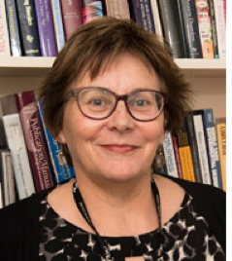
Dr Jenny Jordan
'The other cognitive problem in depression-should we be utilising cognitive re-mediation in CBT'

Jenny Jordan is a senior research fellow and clinical psychologist in the Clinical Research Unit, a collaboration between the Canterbury District Health Board and the Department of Psychological Medicine, University of Otago, Christchurch.
Her primary research focus has been related to our comparative psychotherapy trials for mood and eating disorders; and more recently, research related to earthquake-related trauma, and evaluation of group transdiagnostic CBT with CDHB colleagues at the Anxiety Disorders Service. Most of the clinical trials have included CBT in comparison to other therapies.
Jenny will provide an overview of the literature into cognitive impairment and cognitive remediation for those with depression and will present related findings from recent studies at the Department of Psychological Medicine.
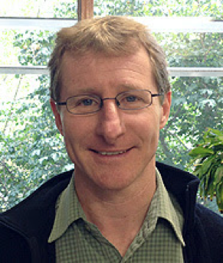
Dr Martin Dorahy
'Shame in the treatment of those presenting with trauma disorders: Presentation issues and therapeutic considerations'

The successful treatment of traumatised clients is impeded by the presence and activation of the self-conscious emotion of shame. Those exposed to trauma, especially that of a relational nature, are prone to experience elevated levels of shame, and thus being aware of, and dealing with, shame in the therapeutic setting becomes a means of not only more fully engaging the individual but maximizing treatment effectiveness. This paper provides an understand of the psychology of shame and examines its correlates including dissociation and different methods to manage it. The paper then examines issues associated with the presentation of shame, and looks at targets for treatment, especially those that might reduce shame in the therapeutic relationships, including exploring cognitions around self-disgust and self-dissmell, which can then provide a foundation for exploration of the person’s traumatic history.

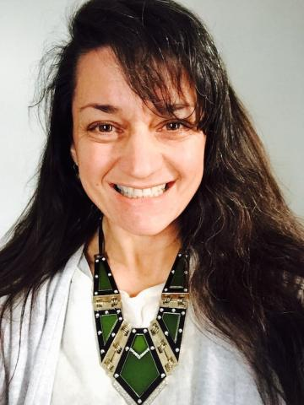
Leonna Manna
Cultural Workshop
The Te Pounamu Model.

Utilising models that can be applied to clinical use alongside Maori has been in development for many years amongst Maori clinicians as well as those who accept that cultural competence requires ongoing development. Te Pounamu has been used to illustrate a visual formulation of a presenting ‘tangata whaiora’s’ difficulties within which CBT terms can be applied. Leona has an interest in Maori Models of Health, assisting with increasing the knowledge of students each year. She applies her experience as a Maori clinical psychologist as an ACC psychology advisor, presenter and supervisor as well as working and assessing Maori in the area of sexual abuse.

Carol Christopher
What Prisoner?
Carol Christopher is a Registered Mental health nurse with additional training in CBT from Massey University. She is currently working at the only maximum secure prison in New Zealand–Auckland Men’s Prison as a Mental Health Clinician in a 2 year pilot, contracted to the Non-Government Organisation (Emerge Aotearoa) to deliver mental health interventions to Offenders serving a prison sentence. She has previously worked in the UK as part of the IAPT initiative in primary care mental health, secondary mental health services and public health.
The prison population is three times more likely to present with mild to moderate mental health issues than the general population and when these issues are targeted reoffending rates also reduce making Aotearoa a safer place to live for all. Carol will discuss delivering CBT focused mental health interventions to this population.

POST CONFERANCE WORKSHOP
Saturday November 25th 2017
Dr David A.Clark
'Modified CBT for persistent Anxiety and Obsessions'

Approximately two-thirds of individuals with an anxiety disorder achieve clinically significant symptom improvement with standard cognitive behavior therapy (CBT) but only 25% - 40% achieve symptom-free status. Thus a significant number of anxious clients (25%-33%) achieve only limited treatment response. This one-day workshop addresses the problem of failed or, at best, minimal response to CBT in the anxiety disorders as well as OCD. It begins with an analysis of treatment failure, the nature of treatment-resistant anxiety, and the limitations of standard CBT. The remainder of the workshop focuses on innovations in theory, assessment, case conceptualization, cognitive restructuring, and behavioral experiments that target specific features of treatment resistant anxiety and obsessional rumination. This is an intermediate level workshop intended for mental health professionals with at least a basic understanding of CBT and clinical experience in the treatment of anxiety and OCD.
Workshop participants will learn to:
a) address poor treatment response in order to prevent discontinuation,
b) incorporate resistance issues into case formulation and goal setting,
c) tailor psychoeducation to increase “buy-in” of reluctant clients,
d) modify cognitive and behavioral strategies that target emotional reasoning, distress intolerance, and homework noncompliance,
e) treat excessive mental control effort, and
f) target excessive fear of losing control.

